Тема: Достопримечательности России
Цель: расширение словарного запаса, самостоятельная работа со словарём
Задание 1: Прочтите и письменно переведите текст

Red Square
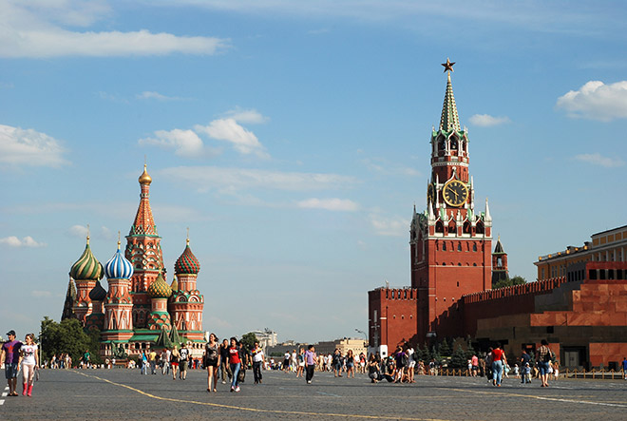Red Square is one of the most famous Russia’s places of interest. It is located right in the heart of Moscow.
Many significant buildings surround Red Square. There is the Kremlin, Lenin’s Mausoleum, Saint Basil’s Cathedral, GUM trading house and Kazan Cathedral there. The State Historical Museum is also located in the square.
Red Square is the place where a lot of festivals are celebrated.

The Kremlin
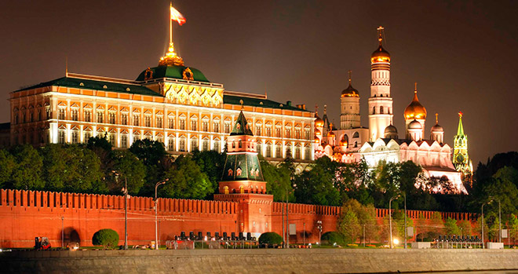The Kremlin is a fortified complex in the centre of Moscow. It is the main political and historical place of the city.
The walls of the Kremlin are made in the form of an irregular triangle. The Troitskaya Tower is the tallest tower of the Kremlin. Its height is 80 metres. The Spasskaya Tower features the clock which is known as the Kremlin chimes. The Kremlin has 20 towers in total.
Today the Kremlin is the official residence of the President of Russia.

The Hermitage
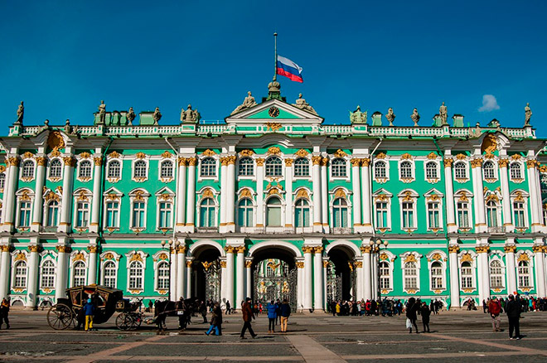The Hermitage is one of the world’s largest museums. It is located in Saint Petersburg. It consists of 5 buildings. The museum’s collection houses about 3 million different works of art.
From the very beginning the Hermitage was Catherine’s II private collection of paintings, but in the time of Nicholas I the Hermitage opened for general public. This happened in 1852.

Saint Basil’s Cathedral
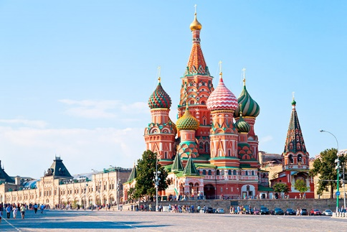Saint Basil’s Cathedral is located in Red Square. This Orthodox church is a world-famous landmark. The church was built in the XVI century by order of Ivan the Terrible. There are 11 domes in Saint Basil’s Cathedral. Its height is 65 metres.
In the XX century the church was open for public as a museum. It is one of the most recognizable tourist attractions. Saint Basil’s Cathedral is included in the list of UNESCO World Heritage Sites.

Lake Baikal
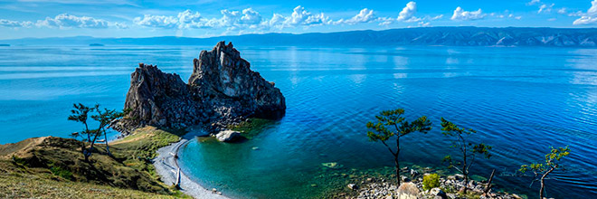Lake Baikal is a lake located in eastern Siberia. This is the deepest lake on our planet and the largest natural reservoir of fresh water.
Lake Baikal is also widely known for its endemic fauna. Water in the lake is very clean and clear. There are 27 islands and the biggest one is called Olkhon.
Numerous rivers and streams flow into Lake Baikal. The Angara is the only river that flows out from the lake.

Petergof
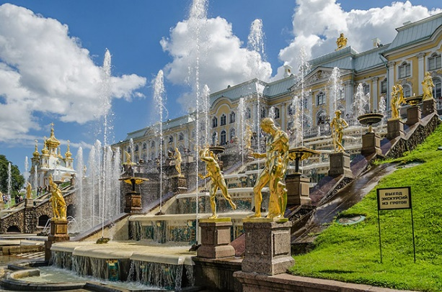Petergof is a small town which has great tourist and scientific significance. In the XVIII century the emperor’s country residence was located there.
The town is located not far from Saint Petersburg and is well-known for its landmarks. These places of interest include the palace ensemble called Petergof with its numerous fountains, alleys and the Peterhof Grand Palace.

The Golden Ring
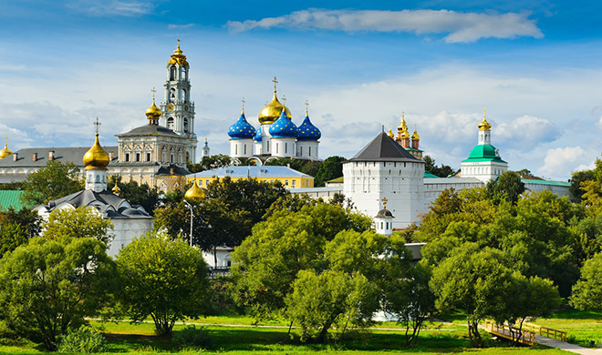The Golden Ring is a ring of cities located not far from Moscow. This popular tourist route runs through ancient cities of Russia which played a significant role in the formation of the Russian Orthodox Church.
There are many unique monuments in these cities which attract a lot of tourists. The cities included in the Golden Ring are Sergiyev Posad, Pereslavl-Zalessky, Rostov Veliky, Yaroslavl, Kostroma, Ivanovo, Suzdal and Vladimir.

The Kizhi Pogost
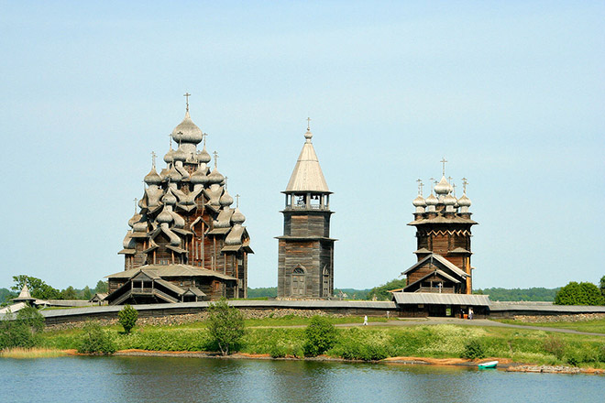Kizhi island is famous for its architectural complex which consists of two wooden churches and a bell-tower. It was built in the XVIII-XIX centuries.
According to the Russian carpentry traditions of that time, the Church of the Transfiguration was built of wood only with no nails.
The second church, the Church of the Intercession, is an architectural echo of the main church. The bell-tower is located right beside them.
Mamayev Kurgan
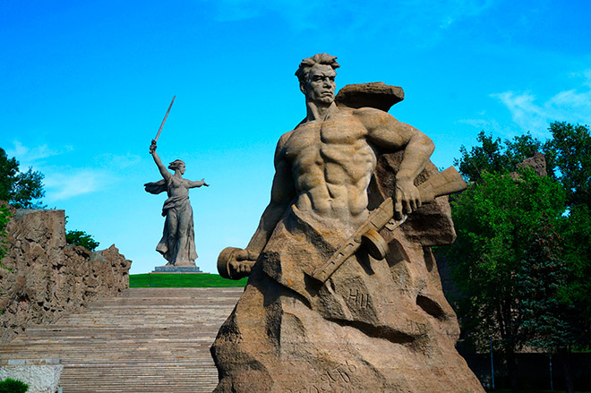Mamayev Kurgan is famous for its memorial complex «The Motherland Calls».
The central figure of the complex is a statue of a woman holding a sword. The height of the sculpture is 85 metres from the feet to the tip of the sword.
This complex commemorates the Battle of Stalingrad. Mamayev Kurgan was the place where fierce fighting occured.

Saint Isaac’s Cathedral
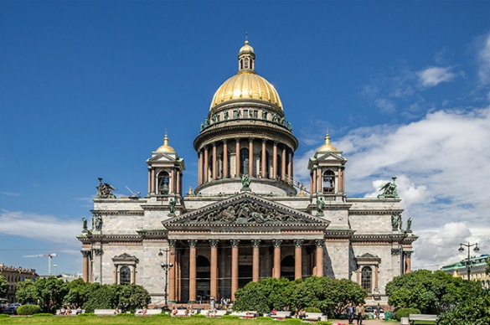Saint Isaac’s Cathedral is located in Saint Petersburg. It is one of the largest cathedrals in the world. The construction of the cathedral took 40 years.
The height of the cathedral is 101,5 metres. The exterior of the cathedral features a lot of columns and statues.
Nowadays, Saint Isaac’s Cathedral is a museum. However, services are conducted there on feast days.

Задание 2: Напишите небольшое сообщение на английском языке, какую достопримечательность Вы бы включили в эту подборку и почему.
Срок сдачи до 28.11.21; выполненные задания присылать документом Microsoft Word, на почту mimikrio@mail.ru, указав в теме фамилию и номер группы.

