Тема: Восточная кухня
Цель: расширение словарного запаса, закрепление материала
Задание 1: Прочитайте и переведите текст
Задание 2: Ответьте на вопросы
Chinese food
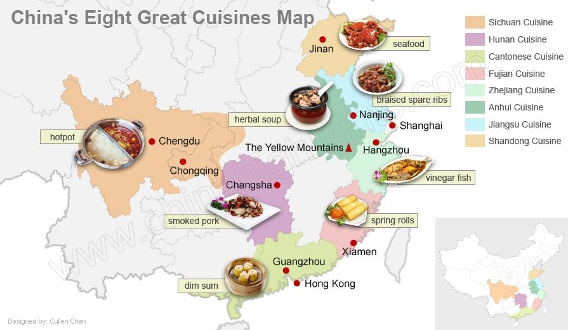
Chinese food is famous all over the world, but you may be shocked by its surprising range and variety of ingredients if you’ve only eaten in Chinese restaurants abroad. Chinese food has countless delicious and fantastic dishes. And people from different areas have different cuisine types, which can be bland, sweet, salty, spicy, or sour.

China’s Regional Food Types
China can be divided into several regions with distinct styles of cooking. The ingredients used are based on the natural and agricultural products of each region.
Northern China food — salty, simple, less vegetables with wheat as the staple food. Food using wheat as its main ingredient, such as noodles and dumplings is prevalent there. Northerners tend to eat more (red) meat and dairy, as the calories, fat, and protein strengthen their bodies against the chilly weather.
Western China food — hearty halal food
There is no pork or carnivorous animals on the menu. Wheat is the main staple grain, and a few vegetables are grown there, mostly onions, carrots, peppers, eggplants, and tomatoes. Xinjiang is also famous for its fruit, particularly dried fruit.
Protein foods include mutton top of its ingredients list, beef, camel meat, horse meat, and various dairy foods.
Central China food — spicy with a lot of seasonings. It is characterized by lots of preserved foods, particularly pickled vegetables and tofu, which give it its sour flavor.
Eastern China food — sweet and light. Eastern food features an abundant use of seafood, fish, pork, poultry, a wide variety of vegetables. Both rice and wheat are common staples.
Southern minority food — sour, and many minorities eat chilies every day.
Southern ethnic food is typically simple and full of natural ingredients, with little wastage. Heads, feet, and innards are all eaten. Pickling in brine or vinegar, sun-drying, and curing were traditionally the only ways to preserve foods in the damp southern weather. The "mountain peoples" pickle vegetables, tofu, and chilies; smoke meat, poultry, fish, and tofu; and sun-dry fruits, fish, vegetables, and chilies.
Tastes of Chinese food are traditionally categorized into five flavors: salty, spicy, sour, sweet, and bitter.
Chinese emphasize "he" harmony of five flavors. According to traditional Chinese medicine, the harmony of the five flavors can not only improve taste enjoyment, but also have the function of achieving balance to promote health, as well as treating diseases and aiding recovery from injury.
Chinese food has a distinctive culinary style all its own. The emphasis is on fresh, seasonal ingredients, prepared with a minimum of fuss and beautifully balanced for color, texture, and presentation.

Questions for the text.
- What tastes can be Chinese food?
- What are the main features of Northern China food ?
- What are the main dishes of Western China food?
- What products include protein?
- What are the main dishes of Central China food?
- How can you characterize dishes of Eastern China food ?
- What are the main dishes of Southern minority food?
- What five flavors of Chinese food are traditionally categorized into?
- What way do Chinese cook?

Срок сдачи до 31.10.21; выполненные задания присылать документом Microsoft Word, на почту mimikrio@mail.ru, указав в теме фамилию и номер группы.

